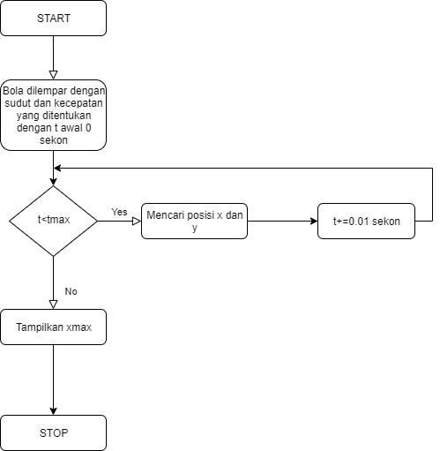

Jeihan Aulia Ramdhani

18318022